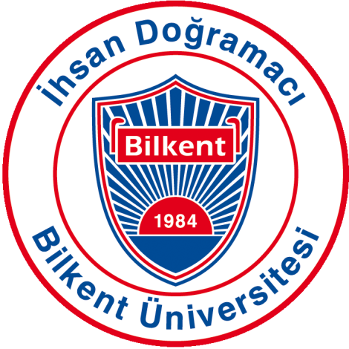Bilkent University

Department of Computer Engineering

Object-Oriented Software Engineering Term Project

TrackIn: Intern Tracking System

Prototype Report

**Group 3G:**

Muammer TAN, Ali Semi YENİMOL, I. Kayacan KAYA, Eniselda TUSKU

**Introduction:**

TrackIn is a web based application that provides companies, interns and supervisors with an easier way to manage the internship procedure. Before internship starts, company matches the intern with an available supervisor who will follow the intern’s entire process in the company. Interns will be able to get tasks from supervisors, point out their completed assignments online and retrieve all the necessary documents which will be provided to him by the company. Supervisors can assign tasks to interns and when they are notified that the given task is done, they can go in order to check and later approve the given task on the system. Also, interns and supervisors will be able to make a scheduler, note their plans, jobs and meetings on calendar. Company can announce any event to the interns such as meeting, seminar, dinner, party etc. on the events page. After a certain time completing his tasks, the intern is assigned a checkpoint, which will be to complete weekly parts of internship report. After the intern has completed the report in the end of his internship he will upload it to the system, form where the company sends it to the department secretary of the intern, so the student will be excluded from the exhausting delivering report stage.

**Current Progress:**

Regarding the project we are working on the code implementation and until now we have built the classes in different subsystems and altered several of them compared to the initial design. We are currently working and improving the connection of the database with our system so it can be fully functional.

* Internship Subsystem:

Several differences have been made in the class hierarchy of the internship Subsystem. Internship class will not be implemented for now an their functionalities have been implemented into “Company”, “Intern” and “Supervisor”, “Department” Classes. The methods that were defined in the “Internship Class” are implemented especially in “Department and “Supervisor” classes. For example “addTask” method which was firstly designed in the implementation of the “Internship” class, will be called by the “Supervisor” which triggers a method inside the “Intern” class that adds the task to the intern. Similarly several more methods have been transferred changing the design of the class diagram.

* Task Management Subsystem:

In the task management subsystem during implementation phase one of the differences made, is that the “Internship Class” subclass is merged in the “Task” class. This changes the class diagram of the system but also makes the code more compact and functional. We still preserved the “General Events” and “Document Task” due to their unique features.

* Account Management Subsystem:

In the account management subsystem no changes have been made in the class diagram and its relation to the database has been established.

* Database Subsystem:

The database is build and it is still in improvement process regarding to the connections with all the other subsystems. A connector class has been implemented which connects the database with the java source code.

* User Interface:

User interface regarding to all the users and functionalities is being built and improved. The user login and profiles have been created and we are thinking of ways to improve the interface.

Overall the project is in very good progress and we are happy with its functionality until this phase. More improvement will be done until the final version.